Beach-Side RC Oil Cleaning Machine: An Embedded Systems Approach for
Coastal Oil Spill Recovery

Submitted by:

Dela Cruz, Denver M.
Delin, Princess Angel G.
Merano, John Lloyd S.
Sombilon, Lyndhel M.
Alejandro, Jhonzen Carl C.
Escuterio, Kazz Denielle
Magararu, Joanne
Malabha, Jay-ar
Magno, Carlo Jose

March, 2026

Table of Contents

Table of Contents
Project Overview 3
Project Description 3
Problem Statement 3
Objectives 3
General Objective 3
Scope and Limitations 3
Scope of the Study 4-5
Limitations of the Study 4
System Architecture 6
Architecture Description 6-8
Data Flow 9-10
Hardware Components 10
Software Components 10
Functional Requirements………………………………………………………………………………………………..…..10-12
Non-Functional Requirements………………………………………………………………………………………………12-13
System Operation Procedure………………………………………………………………………………………….……13-15
Expected Output…………………………………………………………………………………………………….………..15-16
Development Period………………………………………………………………………………………………….………….16
Proof of System Functionality……………………………………………………………………………………….………….16
Source Code………………………………………………………………………………………………………………….16-30

​
​
​
​
​
​
​
​

​
Project Overview

Project Description

This project presents the development of a small-scale beach-side oil cleaning machine designed for efficient removal of oil contaminants in coastal and shoreline environments. The system utilizes a rotating oleophilic drum mechanism that selectively attracts and collects oil while minimizing water intake. As the drum rotates, oil adheres to its surface due to its oil-attracting properties. A scraper blade mechanism removes the collected oil from the drum and directs it into a collection tray, which then transfers the oil into a sealed storage tank located at the rear section of the machine. The machine is mounted on a wide-wheel mobility system, enabling stable movement on sand and shallow shoreline areas. It is powered by a battery system with optional solar support, ensuring energy efficiency and extended operation time. An embedded microcontroller (ESP32) controls the system’s operations, including motor control and sensor monitoring. The machine is equipped with a wireless remote-control system, allowing the operator to control movement (forward, reverse, turning) and activate the oil collection mechanism from a safe distance. Additionally, the system includes obstacle detection sensors to enhance safety by preventing collisions during operation. Overall, the project demonstrates the application of embedded systems in developing a compact, automated oil spill cleaning solution for coastal environments.

Problem Statement
Oil contamination in coastal areas poses serious threats to marine ecosystems, public health, and tourism. Traditional oil spill cleanup methods are often labor-intensive, inefficient, and require direct human exposure to hazardous substances.
The study aims to address the following problems:
- Labor-Intensive Cleanup Process
Oil removal is often done manually using absorbent materials, requiring significant effort and time.
- Inefficient Oil Collection Methods
Conventional methods may fail to effectively separate oil from water, leading to incomplete cleanup.
- Health and Safety Risks
Workers are exposed to toxic oil substances, extreme heat, and prolonged physical strain.
- Lack of Compact and Affordable Equipment
Most oil spill cleanup machines are large, expensive, and unsuitable for small coastal areas.
- Limited Accessibility in Shoreline Areas
Large machines cannot operate efficiently in shallow waters and sandy beach environments.
- Absence of Automated Oil Collection Systems
Many methods lack continuous and automated oil recovery mechanisms.
- Limited Application of Embedded Systems in Oil Cleanup
There is limited development of compact, embedded system-based oil cleaning machines.

Objectives

General Objective

To design and develop a compact embedded system–based beach-side oil cleaning machine that automates oil collection and enables remote-controlled operation for efficient coastal cleanup.

Specific Objectives
The study aims to achieve the following specific objectives:
- To reduce manual labor by developing an automated oil collection mechanism using an oleophilic rotating drum.
- To improve oil recovery efficiency by selectively collecting oil while minimizing water intake.
- To enhance worker safety by enabling remote-controlled operation.
- To design a compact and cost-effective oil cleaning machine suitable for shoreline environments.
- To implement an automated oil collection and storage system.
- To improve maneuverability using a wide-wheel mobility system.
- To demonstrate the use of embedded systems in environmental cleanup applications.

Scope and Limitations

Scope of the Study
This study focuses on the design and development of a compact, beach-side oil cleaning machine utilizing embedded systems technology. The system is intended to assist in small-scale oil spill mitigation along shorelines through a portable and remotely operated solution.
Specifically, the study covers the following components and functionalities:
- Design and fabrication of an oleophilic drum mechanism for efficient oil collection from the water surface
- Development of an oil scraping and storage system to separate and contain collected oil
- Implementation of embedded motor control using ESP32, enabling automation of the drum, drive motors, and boom arm
- Integration of a remote-control system for maneuvering the machine and controlling its operational functions, including the boom arm deployment
- Development of a wide-wheel mobility system to ensure stable movement on sandy terrain
- Design of a floating skimmer attachment, connected via a boom arm, for effective oil collection at the shoreline
- Testing and evaluation in controlled or small-scale shoreline environments to assess functionality, efficiency, and reliability
This study aims to demonstrate the feasibility and effectiveness of a compact oil cleaning solution for localized use. However, it is not intended to replace large-scale industrial oil spill recovery systems, but rather to serve as a supplementary, low-cost alternative for early response and small-area applications.

Limitations of the Study
This study is subject to several limitations related to design scope, resources, and testing conditions. These limitations are acknowledged to provide a clear boundary of the system’s capabilities and applicability.
- The developed machine is designed for small-scale oil spill scenarios only and is not suitable for large or deep-water oil spill operations.
- The system operates primarily in calm or low-wave shoreline environments; performance may be reduced in areas with strong waves, currents, or rough sea conditions.
- The oleophilic drum mechanism is limited in capacity and efficiency, and may not effectively collect all types of oil, especially those that are highly viscous or mixed with debris.
- The floating skimmer attachment relies on proper buoyancy and balance; instability may occur under uneven wave motion or improper weight distribution.
- The remote-control operation depends on signal range and stability, which may be affected by environmental interference or distance from the operator.
- The hose-based oil transfer system relies on gravity flow; therefore, efficiency may decrease if the tank position is not properly aligned or if flow resistance occurs.
- The prototype is constructed using locally available and cost-effective materials, which may not reflect the durability, efficiency, or performance of industrial-grade components.
- Testing is conducted only in controlled or simulated environments, which may not fully represent real-world oil spill conditions.
- The study focuses on design, development, and initial testing, and does not include long-term durability analysis, large-scale deployment, or environmental impact assessment.
These limitations highlight that the developed system is intended as a proof-of-concept and supplementary solution, rather than a complete replacement for professional oil spill response technologies.

System Architecture
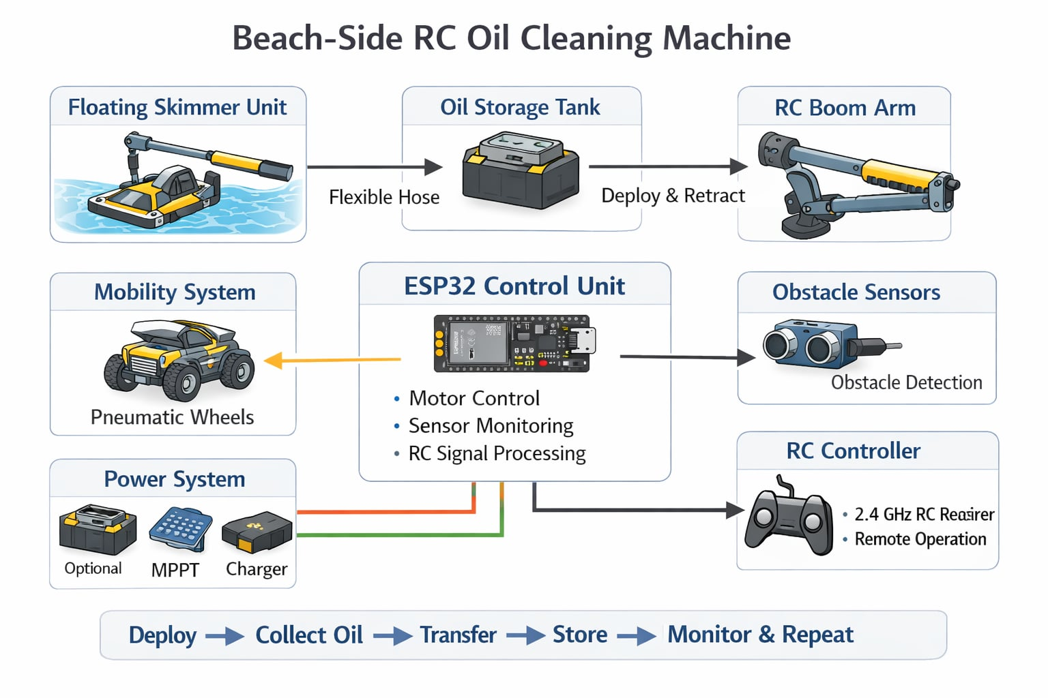

Figure 1: System Architecture
Architecture Description

The system architecture illustrates the interaction between the floating oil collection mechanism, embedded control unit, mobility system, power system, and remote-control interface. The design follows a land-based deployment model, where the machine operates from the shoreline while the oil skimmer performs collection on the water surface.

1. Oil Collection and Separation System (Floating Skimmer Unit)
The oil collection process is performed by a floating skimmer head attached to a boom arm extending from the main machine.
The skimmer consists of a pontoon-supported oleophilic drum mechanism that operates directly on the water surface:
- The oleophilic drum rotates while partially submerged in oil-contaminated water
- Oil selectively adheres to the drum surface
- A scraper blade removes the collected oil from the drum
- Oil flows into a collection tray within the floating unit
- Oil is transferred through a flexible hose connected to the main machine
- Oil is stored in a rear-mounted sealed storage tank
This configuration enables efficient oil recovery while minimizing water intake and maintaining stability on uneven wave conditions.

2. Boom Arm Deployment System (RC-Controlled)
The boom arm connects the main machine to the floating skimmer and provides controlled deployment:
- The arm is remotely controlled using a linear actuator or high-torque servo
- During transport, the arm is folded and secured in a docking cradle
- At the shoreline, the arm is extended and lowered to position the skimmer onto the water surface
- A hinge or universal joint allows vertical movement, enabling the skimmer to adapt to wave motion
- The hose is routed along the boom arm using clips for organized cable management
This system ensures smooth transition between transport and operation modes.

3. Mobility System
The machine utilizes a four-wheel configuration optimized for sandy terrain:
- Rear wheels: 300 mm diameter × 120 mm width (wide pneumatic tires)
- Front wheels: 150 mm caster wheels
This configuration provides:
- Improved weight distribution
- Reduced sinking on soft sand
- Enhanced maneuverability and stability

4. Embedded Control System (ESP32)
The ESP32 serves as the central processing unit of the system.
It is responsible for:
- Drive motor control (movement and steering)
- Drum motor control (oil collection)
- Boom arm actuator control (deployment and retraction)
- Processing remote-control signals
- Monitoring system status (battery, sensors)
The ESP32 enables real-time control and integration of all subsystems.

5. Obstacle Detection System
The system incorporates ultrasonic sensors for safety:
- Detects obstacles within a range of approximately 30 cm
- Automatically stops or restricts movement when obstacles are detected
- Prevents collisions during operation
This ensures safe navigation, especially in cluttered shoreline environments.

6. Power Management System
The system is powered by a hybrid energy setup:
- Primary Source: 24V Lithium Battery
- Optional Source: 100W Solar Panel
- Charge Controller: MPPT (Maximum Power Point Tracking)
- Voltage Regulation: Step-down converters for component-level requirements
This configuration supports extended operation and efficient energy utilization.

7. Oil Storage System
Collected oil is stored in a rear-mounted sealed tank:
- Capacity: 10–15 liters
- Designed to be removable for easy disposal and maintenance
- Positioned lower than the skimmer to enable gravity-assisted oil flow

8. Remote Control Interface
The system is operated using a 2.4 GHz RC controller, providing the following functions:
- Forward / Reverse movement
- Left / Right steering
- Start / Stop drum rotation
- Boom arm control (extend/retract/lower)
- Emergency stop
This allows full remote operation from a safe distance.

9. Continuous Operation Cycle
The system follows a continuous loop:
Deployment → Oil Collection → Transfer → Storage → Monitoring → Repeat
Detailed sequence:
- Machine is positioned at shoreline
- Boom arm deploys floating skimmer
- Drum rotates and collects oil
- Scraper removes oil into tray
- Oil flows through hose into storage tank
- Sensors and system status are monitored
- Cycle repeats until operation ends

Data Flow

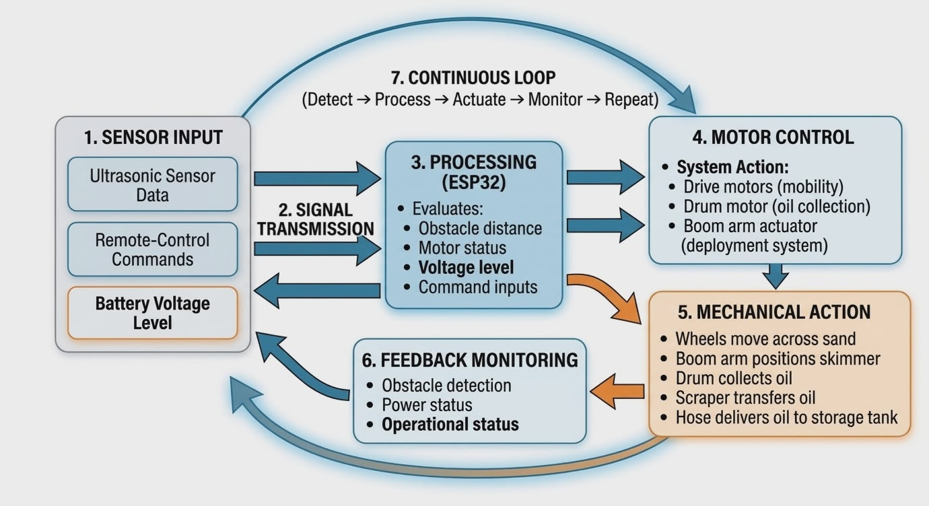







Figure 2: Data Flow

The data flow of the system describes how control signals and sensor information move through the system:

Sensor Input → Processing → Motor Control → Mechanical Action → Feedback Monitoring

1. Input
- Ultrasonic sensor data
- Remote-control commands
- Battery voltage monitoring

2. Signal Transmission
All input signals are transmitted to the ESP32 for processing.

3. Processing
The ESP32 evaluates:
- Obstacle distance
- Motor status
- Battery level
- Command inputs

4. Motor Control
The controller activates:
- Drive motors (mobility)
- Drum motor (oil collection)
- Boom arm actuator (deployment system)

5. Mechanical Action
- Wheels move the machine across sand
- Boom arm positions the skimmer
- Drum collects oil
- Scraper transfers oil
- Hose delivers oil to storage tank

6. Feedback Monitoring
- Obstacle detection
- Power status
- System safety conditions

7. Continuous Loop

Detect → Process → Actuate → Monitor → Repeat

Ensures real-time response and safe operation.

Hardware Components

Component | Description | Minimum Requirement | Recommended Requirement
Microcontroller | Central control unit | Arduino Uno | ESP32
Motor Driver | High current motor control | L298N | BTS7960
Drive Motors | Mobility System | 12V DC motor | 12V High-Torque Gear Motor (150 RPM)
Drum Motor | Oil drum rotation | 12V DC motor | 60RPM Gear Motor
Boom Actuator | Arm control | Servo Motor | Linear actuator (12v)
Ultrasonic Sensors | Obstacle detection | 1 sensor | 3 HC-SR04 sensors
Remote Control Receiver | RC communication | Basic 2.4 GHz | Futaba / FlySky 2.4 GHz
Solar Panel | Auxiliary power | 50W | 100W
Battery | Energy storage | 12V 10Ah | 24V 40Ah Lithium
Solar Charge Controller | Regulates charging | PWM | MPPT
Frame | Structural support | steel | Aluminum square tubing
Wheels | Mobility | Standard rubber | Pneumatic, 300x120mm diameter
Oil Drum | Oil Collection | Basic Roller | Oleophilic-coated drum
Floating unit | Skimmer support | N/A | Dual Pontoon (PVC/Foam)
Hose | Oil Transfer | Basic tubing | Oil-resistant flexible hose
Oil Tank | Storage | Container | Sealed 10-15L tank

Software Components

Software | Purpose | Minimum Requirement | Recommended Requirement
Arduino IDE | Firmware development and code uploading | Arduino IDE 1.8+ | Arduino IDE 2.x
ESP32 Board Package | ESP32 compatibility and board support | Basic ESP32 Board Package | Latest ESP32 Board Packagev
Remote Web Control System | Sends movement and control commands through browser | Local Network Access | Real-Time Wireless Control

Functional Requirements

This section discusses the core functional requirements of the beach-side oil cleaning machine. Each requirement defines a specific behavior that the system must perform to ensure efficient, safe, and automated oil spill cleanup operations.

1. The system shall collect oil using an oleophilic drum

The system is required to collect oil contaminants from the water surface using an oleophilic rotating drum mechanism. The drum attracts and retains oil while minimizing water absorption. As the drum rotates, oil adheres to its surface and is continuously collected. This function enables efficient and selective oil recovery in shoreline environments.

2. The system shall remove and transfer collected oil

After oil adheres to the drum, the system must remove the collected oil using a scraper blade mechanism. The scraped oil is directed into a collection tray and transferred through a hose into a storage tank. This process ensures continuous oil collection and proper handling of recovered contaminants.

3. The system shall store collected oil in a sealed tank

The system must store the collected oil in a sealed storage tank located in the machine. The tank must securely contain the oil to prevent leakage and contamination. This function ensures safe storage and easy disposal of collected oil after operation.

4. The system shall enable remote-controlled operation

The system must be controlled using a wireless remote-control interface. The operator shall be able to:
- Move the machine forward and backward
- Steer left and right
- Start and stop the oil collection drum
- Control the boom arm (extend, retract, and lower)
- Activate an emergency stop

This function allows safe and convenient operation from a distance, reducing direct human exposure to hazardous environments.

5. The system shall provide mobility on shoreline terrain

The system must be capable of moving efficiently on sandy and uneven shoreline surfaces using a wide-wheel mobility system. This ensures stable navigation and proper positioning of the machine during oil cleanup operations.

6. The system shall deploy and control a floating skimmer

The system must include a boom arm mechanism that deploys a floating skimmer onto the water surface. The boom arm must be remotely controlled to extend, lower, and retract the skimmer. This function allows effective oil collection directly from the water while the main machine remains on land.

7. The system shall process inputs using an embedded controller

The system must use an embedded microcontroller (ESP32) to process inputs and control operations. The controller shall handle:
- Remote-control commands
- Sensor inputs
- Motor operations

This function ensures real-time coordination of all system components.

8. The system shall detect obstacles and prevent collisions

The system must use ultrasonic sensors to detect obstacles within a defined range. When an obstacle is detected, the system shall automatically stop or restrict movement. This function enhances operational safety and prevents damage to the machine.

9. The system shall monitor system status

The system must monitor key parameters such as battery level, sensor readings, and operational status. This function ensures that the system operates within safe and optimal conditions.

Non-Functional Requirements

This section discusses the non-functional requirements of the beach-side oil cleaning machine. These requirements define the quality attributes of the system and describe how well the system performs its functions.

1. Performance

The system is required to perform oil collection and movement operations in real time with minimal delay. The response time between remote commands and system actions must be within an acceptable range to ensure smooth operation. This requirement ensures efficient cleanup and responsive control during operation.

2. Safety

The system must ensure safe operation by incorporating obstacle detection and an emergency stop function. Remote operation must allow users to maintain a safe distance from hazardous oil-contaminated environments. This requirement minimizes risks to human health and equipment.

3. Reliability

The system must operate consistently under controlled shoreline conditions. All components, including motors, sensors, and control systems, must function without frequent failure. This ensures dependable performance during repeated and continuous use.

4. Efficiency

The system must maximize oil recovery while minimizing water intake. The oleophilic drum mechanism should effectively separate oil from water to improve cleanup efficiency. This requirement ensures optimal use of resources and effective environmental cleanup.

5. Usability

The system must be easy to operate using a user-friendly remote-control interface. Operators should be able to quickly understand and control the system without extensive training. This requirement improves accessibility and ease of use.

6. Maintainability

The system must allow easy maintenance and cleaning of components. The oil storage tank should be removable, and parts should be replaceable using locally available materials. This ensures long-term usability and reduces maintenance costs.

7. Portability

The system must be compact and easy to transport to different shoreline locations. Its design should support mobility and deployment in small-scale environments. This requirement enhances flexibility in field operations.

8. Scalability

The system must be adaptable for future improvements or expansion. Additional features or components may be integrated without significantly affecting system performance. This ensures that the design can evolve with future technological advancements.

9. Environmental Constraints

The system must operate effectively in shallow water and calm shoreline environments. It is not required to function in deep water or rough sea conditions. This requirement defines the operational limitations of the system.

10. Cost Efficiency

The system must be developed using cost-effective materials and components. It should serve as an affordable alternative to large-scale oil spill cleanup equipment. This requirement ensures accessibility for small communities and local applications.

System Operation Procedure

This section describes the step-by-step procedure for operating the beach-side oil cleaning machine. The procedure outlines the normal sequence of actions required to ensure proper system functionality from system startup to oil collection and monitoring.

Step 1: Power On the Machine

Power on the Machine

The oil cleaning machine is powered on using its primary power source, which is a rechargeable battery system. Upon startup, the system initializes all hardware components, including the embedded controller (ESP32), motors, sensors, and remote-control receiver. This step prepares the machine for operation and ensures that all subsystems are functioning properly.

Step 2: System Initialization and Readiness Check

System Initialization and Readiness Check

After powering on, the system performs an automatic initialization process. The ESP32 checks the status of key components such as the ultrasonic sensors, motor drivers, and power levels. Once all components are verified and functioning correctly, the system enters a ready state for operation.

Step 3: Remote Control Activation

Remote Control Activation

The operator activates the remote-control transmitter to establish communication with the machine. Once connected, the operator can send commands to control movement, oil collection, and boom arm operation. This step enables wireless control and safe operation from a distance.

Step 4: Machine Positioning

Machine Positioning

Using the remote control, the operator navigates the machine toward the shoreline area where oil contamination is present. The wide-wheel mobility system allows the machine to move efficiently on sandy and uneven terrain. Proper positioning ensures effective deployment of the oil collection system.

Step 5: Boom Arm Deployment

Boom Arm Deployment

Once the machine is in position, the operator deploys the boom arm using the remote control. The boom arm extends and lowers the floating skimmer onto the water surface. This step ensures that the oil collection mechanism is properly placed for operation.

Step 6: Oil Collection Process

Oil Collection Process

The operator activates the rotating oleophilic drum. As the drum rotates, it attracts and collects oil from the water surface. The scraper blade removes the oil from the drum and directs it into the collection tray. The oil then flows through a hose into the storage tank. This process continues automatically during operation.

Step 7: Continuous Monitoring and Operation

Continuous Monitoring and Operation

While the system is operating, the embedded controller continuously monitors sensor inputs, battery levels, and system status. The obstacle detection system ensures safe navigation by stopping or restricting movement when obstacles are detected. The operator can adjust movement and operations in real time using the remote control.

Step 8: Oil Storage Management

Oil Storage Management
Collected oil is stored in the sealed storage tank located at the rear of the machine. The system ensures that oil is safely contained during operation. The operator may monitor the tank level and stop the operation once the tank reaches its capacity.

Step 9: System Shutdown and Oil Disposal

System Shutdown and Oil Disposal

After completing the cleanup operation, the operator stops the drum and retracts the boom arm using the remote control. The machine is then powered off. The collected oil is removed from the storage tank for proper disposal according to environmental safety guidelines.

Expected Output

The expected outputs of the beach-side oil cleaning machine are the following:

1. Automated Oil Collection System

The system provides an automated oil collection process using an oleophilic rotating drum mechanism. Once activated, the machine continuously collects oil from the water surface without requiring manual intervention, reducing labor and increasing efficiency.

2. Efficient Oil Recovery

The system produces effective oil recovery by selectively collecting oil while minimizing water intake. This improves the overall cleanup performance and ensures better separation of oil contaminants from water.

3. Safe and Remote Operation

The system enables remote-controlled operation, allowing users to control the machine from a safe distance. This reduces direct exposure to hazardous oil substances and improves operator safety during cleanup activities.

4. Continuous Oil Transfer and Storage

Collected oil is automatically transferred from the drum to a sealed storage tank through a hose system. This ensures continuous operation and proper containment of recovered oil for safe handling and disposal.

5. Improved Mobility in Shoreline Areas

The system demonstrates stable and efficient movement on sandy and uneven terrain using a wide-wheel mobility system. This allows the machine to operate effectively in coastal and shoreline environments.

6. Real-Time System Monitoring

The system provides real-time monitoring of operational status, including sensor readings, obstacle detection, and battery levels. This ensures safe and controlled operation throughout the cleaning process.

7. Obstacle Detection and Safety Response

The system is capable of detecting obstacles and automatically stopping or restricting movement to prevent collisions. This enhances operational safety and protects both the machine and its surroundings.

8. Compact and Portable Oil Cleaning Machine

The final output includes a compact and portable machine designed for small-scale oil spill cleanup. Its size and design make it suitable for localized coastal applications.

9. Functional Embedded System Prototype

The system delivers a fully functional embedded system prototype controlled by an ESP32 microcontroller. It demonstrates the integration of sensors, motors, and remote-control technology in an environmental application.

10. Cost-Effective Oil Spill Solution

The project produces a low-cost alternative to large-scale oil spill cleanup equipment. It is designed using accessible materials, making it practical for small communities and local shoreline management.

Development Period
The development period refers to the actual time span during which the system was designed, built, programmed, tested, and finalized. For this project, the development period covers eight (8) weeks, starting from project planning up to final evaluation and documentation. During this period, all major activities, including hardware assembly is being done.

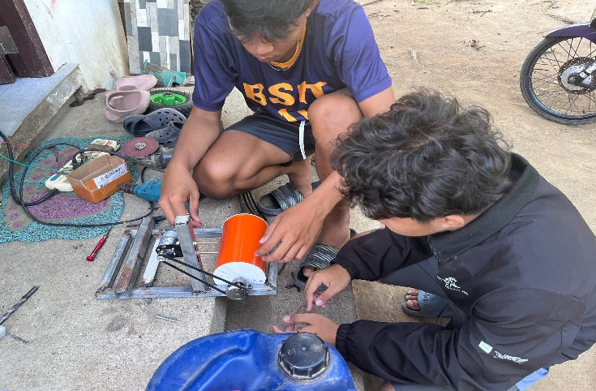

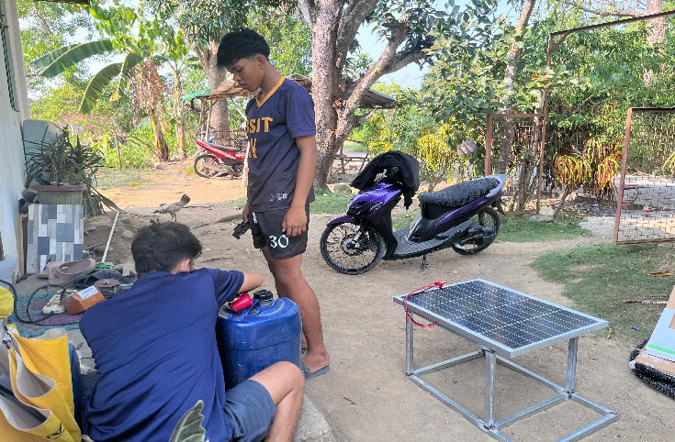

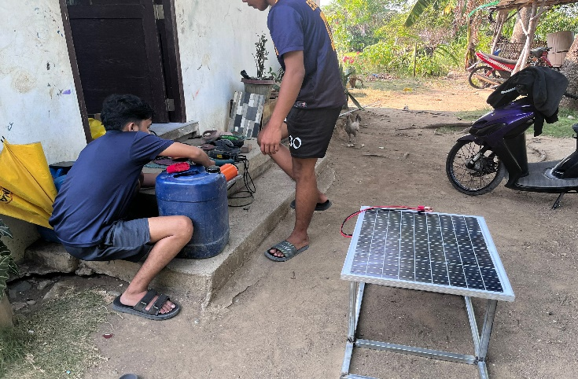

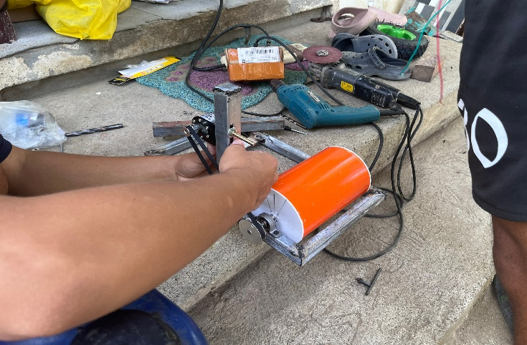

Proof of System Functionality
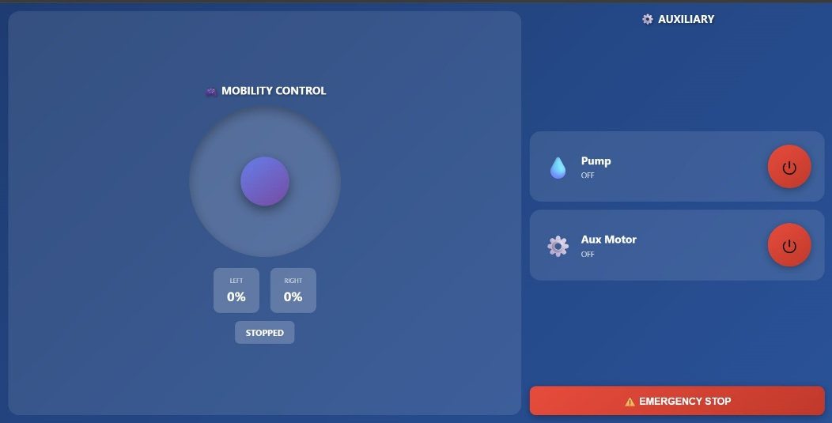

The graphical user interface (GUI) of the system is designed as a wireless web-based control dashboard for the beach-side oil cleaning machine. The interface is divided into two main sections: the mobility control panel and the auxiliary control panel. On the left side, the mobility control section contains a virtual circular joystick that allows the operator to remotely maneuver the machine in different directions, including forward, reverse, left, and right movements. Beneath the joystick are real-time speed indicators for the left and right motors, along with a status display showing the current movement state of the machine. On the right side, the auxiliary control section provides dedicated control buttons for activating and deactivating the pump and auxiliary motor used in the oil collection process. Each auxiliary component includes a visual status indicator showing whether the device is currently turned ON or OFF. At the bottom of the interface is a large emergency stop button that immediately disables all motors and operational components during emergency situations. The interface is developed using HTML, CSS, and JavaScript hosted through the ESP32 web server, enabling wireless access through smartphones, tablets, or computers connected to the same network. The overall design emphasizes user-friendly operation, responsive control, and real-time monitoring for safe and efficient remote operation of the system.
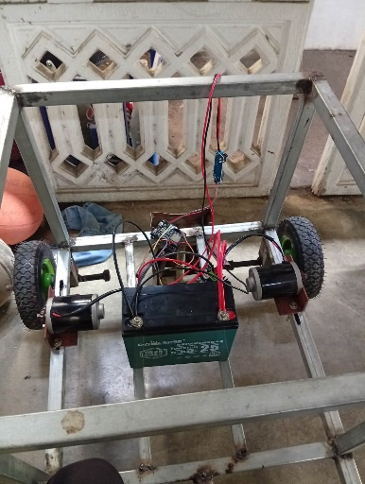

The image shows the prototype of the beach-side oil cleaning machine during assembly. The frame is made of lightweight metal and includes a four-wheel mobility system. A rechargeable battery is mounted at the center to supply power to the motors and control system. Electrical wiring and motor components are installed for integration with the ESP32 controller.

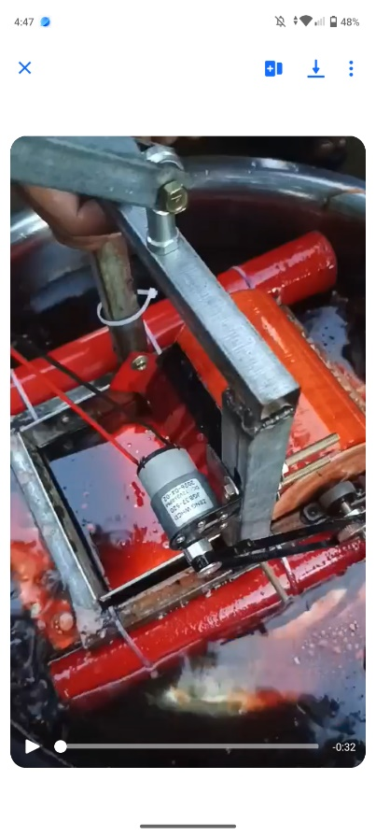

A compact floating machine designed to clean oil spills along beachside waters. It uses a motorized system and floating frame to collect oil and pollutants efficiently, helping protect marine life and keep coastal areas clean.

Source Code
/*
* ESP32 Unified Tank Controller
* - Mobility: Dual BTS7960 motor drivers with circular joystick
* - Auxiliary: Pump and Aux Motor via MOSFET modules
* - Landscape layout with circular toggle buttons
*
* MOBILITY WIRING (BTS7960):
* Left Motor: RPWM=25, LPWM=26, R_EN=27, L_EN=13
* Right Motor: RPWM=32, LPWM=33, R_EN=18, L_EN=19
*
* AUXILIARY WIRING (MOSFET):
* Pump: TRIG/PWM -> GPIO 14, GND -> ESP32 GND
* Aux Motor: TRIG/PWM -> GPIO 12, GND -> ESP32 GND
*/

#include <WiFi.h>
#include <WebServer.h>

// WiFi credentials
const char* ssid = "Galaxy A52s 5GB1D0";
const char* password = "upui9397";

// ===== MOBILITY MOTORS (BTS7960) =====
// Left Motor (BTS7960 Driver #1)
const int RPWM1_PIN = 25;
const int LPWM1_PIN = 26;
const int R_EN1_PIN = 27;
const int L_EN1_PIN = 13;

// Right Motor (BTS7960 Driver #2)
const int RPWM2_PIN = 32;
const int LPWM2_PIN = 33;
const int R_EN2_PIN = 18;
const int L_EN2_PIN = 19;

// ===== AUXILIARY DEVICES (MOSFET) =====
const int PUMP_PIN = 14; // Pump MOSFET control
const int AUX_MOTOR_PIN = 12; // Aux Motor MOSFET control

// PWM settings for mobility motors
const int PWM_FREQ = 20000;
const int PWM_RESOLUTION = 8;

// Motor tuning
const int DEADZONE = 10;
const int PWM_MIN = 60;
const int PWM_MAX = 160;
const int RAMP_STEP = 1;
const unsigned long RAMP_INTERVAL = 25;

WebServer server(80);

// Mobility motor states
int targetSpeed1 = 0;
int currentSpeed1 = 0;
unsigned long lastRampTime1 = 0;

int targetSpeed2 = 0;
int currentSpeed2 = 0;
unsigned long lastRampTime2 = 0;

// Auxiliary device states
bool pumpState = false;
bool auxMotorState = false;

// Helper function
int signOf(int value) {
if (value > 0) return 1;
if (value < 0) return -1;
return 0;
}

// Apply speed to mobility motor
void applyMotor(int motorNum, int speed) {
speed = constrain(speed, -100, 100);

int rpwm_pin, lpwm_pin, r_en_pin, l_en_pin;

if (motorNum == 1) {
rpwm_pin = RPWM1_PIN;
lpwm_pin = LPWM1_PIN;
r_en_pin = R_EN1_PIN;
l_en_pin = L_EN1_PIN;
} else {
rpwm_pin = RPWM2_PIN;
lpwm_pin = LPWM2_PIN;
r_en_pin = R_EN2_PIN;
l_en_pin = L_EN2_PIN;
}

digitalWrite(r_en_pin, HIGH);
digitalWrite(l_en_pin, HIGH);

if (speed == 0) {
ledcWrite(rpwm_pin, 0);
ledcWrite(lpwm_pin, 0);
return;
}

int pwmValue = map(abs(speed), DEADZONE, 100, PWM_MIN, PWM_MAX);
pwmValue = constrain(pwmValue, PWM_MIN, PWM_MAX);

if (speed > 0) {
ledcWrite(lpwm_pin, 0);
delayMicroseconds(200);
ledcWrite(rpwm_pin, pwmValue);
} else {
ledcWrite(rpwm_pin, 0);
delayMicroseconds(200);
ledcWrite(lpwm_pin, pwmValue);
}
}

void stopMotor(int motorNum) {
if (motorNum == 1) {
targetSpeed1 = 0;
currentSpeed1 = 0;
applyMotor(1, 0);
} else {
targetSpeed2 = 0;
currentSpeed2 = 0;
applyMotor(2, 0);
}
}

void stopAllMotors() {
stopMotor(1);
stopMotor(2);
}

void setMotorSpeed(int motorNum, int speed) {
speed = constrain(speed, -100, 100);

if (speed != 0 && abs(speed) < DEADZONE) {
speed = 0;
}

if (motorNum == 1) {
targetSpeed1 = speed;
} else {
targetSpeed2 = speed;
}
}

void updateMotorRamp(int motorNum) {
int *currentSpeed, *targetSpeed;
unsigned long *lastRampTime;

if (motorNum == 1) {
currentSpeed = &currentSpeed1;
targetSpeed = &targetSpeed1;
lastRampTime = &lastRampTime1;
} else {
currentSpeed = &currentSpeed2;
targetSpeed = &targetSpeed2;
lastRampTime = &lastRampTime2;
}

if (*currentSpeed == *targetSpeed) return;

unsigned long now = millis();
if (now - *lastRampTime < RAMP_INTERVAL) return;

*lastRampTime = now;

int currentSign = signOf(*currentSpeed);
int targetSign = signOf(*targetSpeed);

if (currentSign != 0 && targetSign != 0 && currentSign != targetSign) {
if (*currentSpeed > 0) {
*currentSpeed = max(0, *currentSpeed - RAMP_STEP);
} else {
*currentSpeed = min(0, *currentSpeed + RAMP_STEP);
}
} else {
if (abs(*targetSpeed - *currentSpeed) <= RAMP_STEP) {
*currentSpeed = *targetSpeed;
} else if (*targetSpeed > *currentSpeed) {
*currentSpeed += RAMP_STEP;
} else {
*currentSpeed -= RAMP_STEP;
}
}

applyMotor(motorNum, *currentSpeed);
}

// Web page handler
void handleRoot() {
String html = R"rawliteral(
<!DOCTYPE html>
<html>
<head>
<meta charset="UTF-8">
<meta name="viewport" content="width=device-width, initial-scale=1.0, user-scalable=no">
<title>Tank Controller</title>
<style>
* {
margin: 0;
padding: 0;
box-sizing: border-box;
-webkit-tap-highlight-color: transparent;
}

body {
font-family: 'Segoe UI', Tahoma, Geneva, Verdana, sans-serif;
background: linear-gradient(135deg, #1e3c72 0%, #2a5298 100%);
overflow: hidden;
touch-action: none;
}

.landscape-container {
display: flex;
height: 100vh;
width: 100vw;
padding: 15px;
gap: 15px;
}

/* Left side - Joystick */
.joystick-section {
flex: 1;
display: flex;
flex-direction: column;
justify-content: center;
align-items: center;
background: rgba(255, 255, 255, 0.1);
border-radius: 20px;
backdrop-filter: blur(10px);
padding: 20px;
}

.joystick-title {
color: white;
font-size: 20px;
font-weight: bold;
margin-bottom: 15px;
text-shadow: 2px 2px 4px rgba(0,0,0,0.3);
}

.joystick-container {
position: relative;
width: 280px;
height: 280px;
border-radius: 50%;
background: rgba(255, 255, 255, 0.15);
box-shadow: inset 0 8px 20px rgba(0,0,0,0.3);
touch-action: none;
}

.joystick-center {
position: absolute;
top: 50%;
left: 50%;
width: 20px;
height: 20px;
transform: translate(-50%, -50%);
border-radius: 50%;
background: rgba(255, 255, 255, 0.3);
}

.joystick-stick {
position: absolute;
top: 50%;
left: 50%;
width: 90px;
height: 90px;
transform: translate(-50%, -50%);
border-radius: 50%;
background: linear-gradient(145deg, #667eea, #764ba2);
box-shadow: 0 8px 20px rgba(0,0,0,0.4);
cursor: grab;
z-index: 10;
}

.joystick-stick:active {
cursor: grabbing;
}

.motor-info {
display: flex;
gap: 20px;
margin-top: 20px;
}

.motor-display {
background: rgba(255, 255, 255, 0.2);
padding: 15px 25px;
border-radius: 12px;
text-align: center;
}

.motor-label {
color: rgba(255, 255, 255, 0.8);
font-size: 12px;
margin-bottom: 5px;
}

.motor-speed {
color: white;
font-size: 24px;
font-weight: bold;
}

.direction-display {
color: white;
font-size: 16px;
font-weight: bold;
margin-top: 15px;
padding: 10px 20px;
background: rgba(255, 255, 255, 0.2);
border-radius: 8px;
}

/* Right side - Auxiliary Controls */
.aux-section {
flex: 0.6;
display: flex;
flex-direction: column;
gap: 15px;
}

.aux-title {
color: white;
font-size: 20px;
font-weight: bold;
text-align: center;
text-shadow: 2px 2px 4px rgba(0,0,0,0.3);
}

.aux-controls {
flex: 1;
display: flex;
flex-direction: column;
gap: 15px;
justify-content: center;
}

.aux-card {
background: rgba(255, 255, 255, 0.1);
border-radius: 20px;
backdrop-filter: blur(10px);
padding: 25px;
display: flex;
align-items: center;
justify-content: space-between;
}

.aux-info {
display: flex;
align-items: center;
gap: 15px;
}

.aux-icon {
font-size: 40px;
}

.aux-details {
color: white;
}

.aux-name {
font-size: 20px;
font-weight: bold;
margin-bottom: 5px;
}

.aux-status {
font-size: 14px;
opacity: 0.8;
}

/* Circular Toggle Button */
.toggle-button {
width: 80px;
height: 80px;
border-radius: 50%;
border: none;
cursor: pointer;
transition: all 0.3s;
box-shadow: 0 4px 15px rgba(0,0,0,0.3);
font-size: 32px;
display: flex;
align-items: center;
justify-content: center;
}

.toggle-button.off {
background: linear-gradient(145deg, #e74c3c, #c0392b);
}

.toggle-button.on {
background: linear-gradient(145deg, #2ecc71, #27ae60);
}

.toggle-button:active {
transform: scale(0.95);
}

.emergency-stop {
width: 100%;
padding: 15px;
border: none;
border-radius: 12px;
background: linear-gradient(145deg, #e74c3c, #c0392b);
color: white;
font-size: 18px;
font-weight: bold;
cursor: pointer;
box-shadow: 0 4px 15px rgba(0,0,0,0.3);
}

.emergency-stop:active {
transform: scale(0.98);
}

@media (max-width: 768px) {
.landscape-container {
flex-direction: column;
}

.joystick-container {
width: 220px;
height: 220px;
}

.joystick-stick {
width: 70px;
height: 70px;
}
}
</style>
</head>
<body>
<div class="landscape-container">
<!-- Left Side: Joystick Control -->
<div class="joystick-section">
<div class="joystick-title">🎮 MOBILITY CONTROL</div>

<div class="joystick-container" id="joystick">
<div class="joystick-center"></div>
<div class="joystick-stick" id="stick"></div>
</div>

<div class="motor-info">
<div class="motor-display">
<div class="motor-label">LEFT</div>
<div class="motor-speed" id="speedLeft">0%</div>
</div>
<div class="motor-display">
<div class="motor-label">RIGHT</div>
<div class="motor-speed" id="speedRight">0%</div>
</div>
</div>

<div class="direction-display" id="direction">STOPPED</div>
</div>

<!-- Right Side: Auxiliary Controls -->
<div class="aux-section">
<div class="aux-title">⚙️ AUXILIARY</div>

<div class="aux-controls">
<!-- Pump Control -->
<div class="aux-card">
<div class="aux-info">
<div class="aux-icon">💧</div>
<div class="aux-details">
<div class="aux-name">Pump</div>
<div class="aux-status" id="pumpStatus">OFF</div>
</div>
</div>
<button class="toggle-button off" id="pumpBtn" onclick="togglePump()">
⏻
</button>
</div>

<!-- Aux Motor Control -->
<div class="aux-card">
<div class="aux-info">
<div class="aux-icon">⚙️</div>
<div class="aux-details">
<div class="aux-name">Aux Motor</div>
<div class="aux-status" id="auxStatus">OFF</div>
</div>
</div>
<button class="toggle-button off" id="auxBtn" onclick="toggleAux()">
⏻
</button>
</div>
</div>

<button class="emergency-stop" onclick="emergencyStop()">
⚠️ EMERGENCY STOP
</button>
</div>
</div>

<script>
// Joystick variables
const container = document.getElementById('joystick');
const stick = document.getElementById('stick');
const directionText = document.getElementById('direction');
const speedLeftText = document.getElementById('speedLeft');
const speedRightText = document.getElementById('speedRight');

let dragging = false;
let centerX = 0;
let centerY = 0;
let maxDistance = 0;
let lastSentX = 999;
let lastSentY = 999;

// Auxiliary states
let pumpOn = false;
let auxOn = false;

function updateDimensions() {
const rect = container.getBoundingClientRect();
centerX = rect.width / 2;
centerY = rect.height / 2;
maxDistance = centerX - 45;
}

function sendPosition(x, y) {
if (x === lastSentX && y === lastSentY) return;
lastSentX = x;
lastSentY = y;
fetch(`/control?x=${x}&y=${y}`).catch(() => {});
}

function getDirection(x, y) {
const threshold = 15;
if (Math.abs(x) < threshold && Math.abs(y) < threshold) return 'STOPPED';
if (Math.abs(y) > Math.abs(x) * 2) return y > 0 ? 'FORWARD' : 'REVERSE';
if (Math.abs(x) > Math.abs(y) * 2) return x > 0 ? 'TURN RIGHT' : 'TURN LEFT';
if (y > 0 && x > 0) return 'FORWARD RIGHT';
if (y > 0 && x < 0) return 'FORWARD LEFT';
if (y < 0 && x > 0) return 'REVERSE RIGHT';
if (y < 0 && x < 0) return 'REVERSE LEFT';
return 'STOPPED';
}

function updateUI(x, y) {
let leftSpeed = y + x;
let rightSpeed = y - x;
leftSpeed = Math.max(-100, Math.min(100, leftSpeed));
rightSpeed = Math.max(-100, Math.min(100, rightSpeed));

speedLeftText.textContent = Math.abs(Math.round(leftSpeed)) + '%';
speedRightText.textContent = Math.abs(Math.round(rightSpeed)) + '%';
directionText.textContent = getDirection(x, y);
}

function getClientPos(e) {
if (e.touches) {
return { x: e.touches[0].clientX, y: e.touches[0].clientY };
}
return { x: e.clientX, y: e.clientY };
}

function startDrag(e) {
dragging = true;
e.preventDefault();
}

function drag(e) {
if (!dragging) return;
e.preventDefault();

const rect = container.getBoundingClientRect();
const pos = getClientPos(e);
let offsetX = pos.x - rect.left - centerX;
let offsetY = pos.y - rect.top - centerY;

const distance = Math.sqrt(offsetX * offsetX + offsetY * offsetY);
if (distance > maxDistance) {
const angle = Math.atan2(offsetY, offsetX);
offsetX = Math.cos(angle) * maxDistance;
offsetY = Math.sin(angle) * maxDistance;
}

stick.style.transform = `translate(calc(-50% + ${offsetX}px), calc(-50% + ${offsetY}px))`;

const x = Math.round((offsetX / maxDistance) * 100);
const y = Math.round(-(offsetY / maxDistance) * 100);

updateUI(x, y);
sendPosition(x, y);
}

function stopDrag() {
if (!dragging) return;
dragging = false;
stick.style.transform = 'translate(-50%, -50%)';
updateUI(0, 0);
sendPosition(0, 0);
}

function emergencyStop() {
dragging = false;
stick.style.transform = 'translate(-50%, -50%)';
updateUI(0, 0);
lastSentX = 999;
lastSentY = 999;
fetch('/stop').catch(() => {});
}

// Auxiliary control functions
function togglePump() {
pumpOn = !pumpOn;
fetch(`/pump/${pumpOn ? 'on' : 'off'}`)
.then(() => updateAuxStatus())
.catch(() => {});
}

function toggleAux() {
auxOn = !auxOn;
fetch(`/aux/${auxOn ? 'on' : 'off'}`)
.then(() => updateAuxStatus())
.catch(() => {});
}

function updateAuxStatus() {
fetch('/auxstatus')
.then(response => response.json())
.then(data => {
// Update pump
pumpOn = data.pump;
const pumpBtn = document.getElementById('pumpBtn');
const pumpStatus = document.getElementById('pumpStatus');
pumpBtn.className = pumpOn ? 'toggle-button on' : 'toggle-button off';
pumpStatus.textContent = pumpOn ? 'ON' : 'OFF';

// Update aux motor
auxOn = data.aux;
const auxBtn = document.getElementById('auxBtn');
const auxStatus = document.getElementById('auxStatus');
auxBtn.className = auxOn ? 'toggle-button on' : 'toggle-button off';
auxStatus.textContent = auxOn ? 'ON' : 'OFF';
})
.catch(() => {});
}

// Initialize
updateDimensions();
window.addEventListener('resize', updateDimensions);

// Joystick events
stick.addEventListener('mousedown', startDrag);
document.addEventListener('mousemove', drag);
document.addEventListener('mouseup', stopDrag);
stick.addEventListener('touchstart', startDrag, { passive: false });
document.addEventListener('touchmove', drag, { passive: false });
document.addEventListener('touchend', stopDrag);

// Auto-update auxiliary status
setInterval(updateAuxStatus, 2000);
updateAuxStatus();
</script>
</body>
</html>
)rawliteral";

server.send(200, "text/html", html);
}

// Handle mobility control
void handleControl() {
if (!server.hasArg("x") || !server.hasArg("y")) {
server.send(400, "text/plain", "Missing parameters");
return;
}

int x = server.arg("x").toInt();
int y = server.arg("y").toInt();

x = constrain(x, -100, 100);
y = constrain(y, -100, 100);

if (x == 0 && y == 0) {
stopAllMotors();
server.send(200, "text/plain", "OK");
return;
}

int leftSpeed = y + x;
int rightSpeed = y - x;

leftSpeed = constrain(leftSpeed, -100, 100);
rightSpeed = constrain(rightSpeed, -100, 100);

setMotorSpeed(1, leftSpeed);
setMotorSpeed(2, rightSpeed);

server.send(200, "text/plain", "OK");
}

// Handle stop
void handleStop() {
stopAllMotors();
server.send(200, "text/plain", "STOPPED");
}

// Handle pump ON
void handlePumpOn() {
digitalWrite(PUMP_PIN, HIGH);
pumpState = true;
Serial.println("Pump turned ON");
server.send(200, "text/plain", "Pump ON");
}

// Handle pump OFF
void handlePumpOff() {
digitalWrite(PUMP_PIN, LOW);
pumpState = false;
Serial.println("Pump turned OFF");
server.send(200, "text/plain", "Pump OFF");
}

// Handle aux motor ON
void handleAuxOn() {
digitalWrite(AUX_MOTOR_PIN, HIGH);
auxMotorState = true;
Serial.println("Aux Motor turned ON");
server.send(200, "text/plain", "Aux Motor ON");
}

// Handle aux motor OFF
void handleAuxOff() {
digitalWrite(AUX_MOTOR_PIN, LOW);
auxMotorState = false;
Serial.println("Aux Motor turned OFF");
server.send(200, "text/plain", "Aux Motor OFF");
}

// Handle auxiliary status
void handleAuxStatus() {
String json = "{\"pump\":";
json += pumpState ? "true" : "false";
json += ",\"aux\":";
json += auxMotorState ? "true" : "false";
json += "}";
server.send(200, "application/json", json);
}

void setup() {
Serial.begin(115200);
Serial.println("\n\n=== ESP32 Unified Tank Controller ===");

// Initialize mobility motor pins
pinMode(R_EN1_PIN, OUTPUT);
pinMode(L_EN1_PIN, OUTPUT);
pinMode(R_EN2_PIN, OUTPUT);
pinMode(L_EN2_PIN, OUTPUT);

digitalWrite(R_EN1_PIN, LOW);
digitalWrite(L_EN1_PIN, LOW);
digitalWrite(R_EN2_PIN, LOW);
digitalWrite(L_EN2_PIN, LOW);

// Setup PWM for mobility motors
ledcAttach(RPWM1_PIN, PWM_FREQ, PWM_RESOLUTION);
ledcAttach(LPWM1_PIN, PWM_FREQ, PWM_RESOLUTION);
ledcAttach(RPWM2_PIN, PWM_FREQ, PWM_RESOLUTION);
ledcAttach(LPWM2_PIN, PWM_FREQ, PWM_RESOLUTION);

ledcWrite(RPWM1_PIN, 0);
ledcWrite(LPWM1_PIN, 0);
ledcWrite(RPWM2_PIN, 0);
ledcWrite(LPWM2_PIN, 0);

// Initialize auxiliary device pins
pinMode(PUMP_PIN, OUTPUT);
pinMode(AUX_MOTOR_PIN, OUTPUT);
digitalWrite(PUMP_PIN, LOW);
digitalWrite(AUX_MOTOR_PIN, LOW);

Serial.println("All pins initialized");

// Connect to WiFi
Serial.print("Connecting to WiFi: ");
Serial.println(ssid);
WiFi.begin(ssid, password);

while (WiFi.status() != WL_CONNECTED) {
delay(500);
Serial.print('.');
}

Serial.println();
Serial.println("WiFi connected!");
Serial.print("IP Address: ");
Serial.println(WiFi.localIP());

// Setup web server routes
server.on("/", handleRoot);
server.on("/control", handleControl);
server.on("/stop", handleStop);
server.on("/pump/on", handlePumpOn);
server.on("/pump/off", handlePumpOff);
server.on("/aux/on", handleAuxOn);
server.on("/aux/off", handleAuxOff);
server.on("/auxstatus", handleAuxStatus);

server.begin();
Serial.println("Web server started");
Serial.println("===========================================\n");
}

void loop() {
server.handleClient();
updateMotorRamp(1);
updateMotorRamp(2);
}

